1. Enter http://GATEWAY_IP:8080/api in the Firefox browser

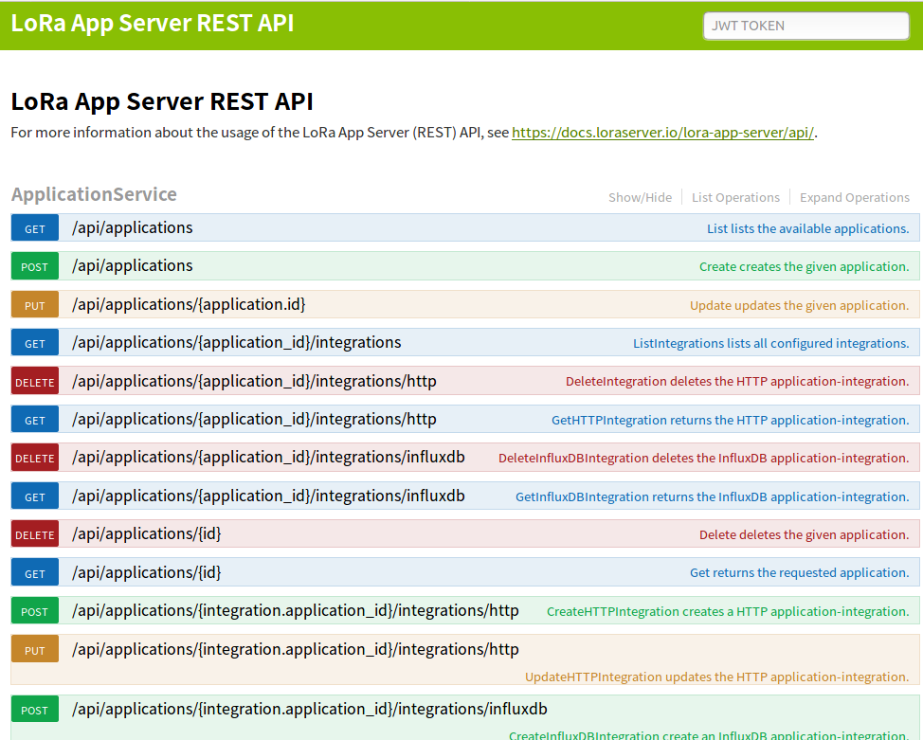

1. Find login

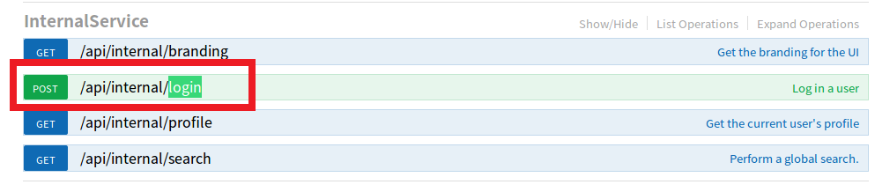

1. Click on “/api/internal/login” to expand as follows

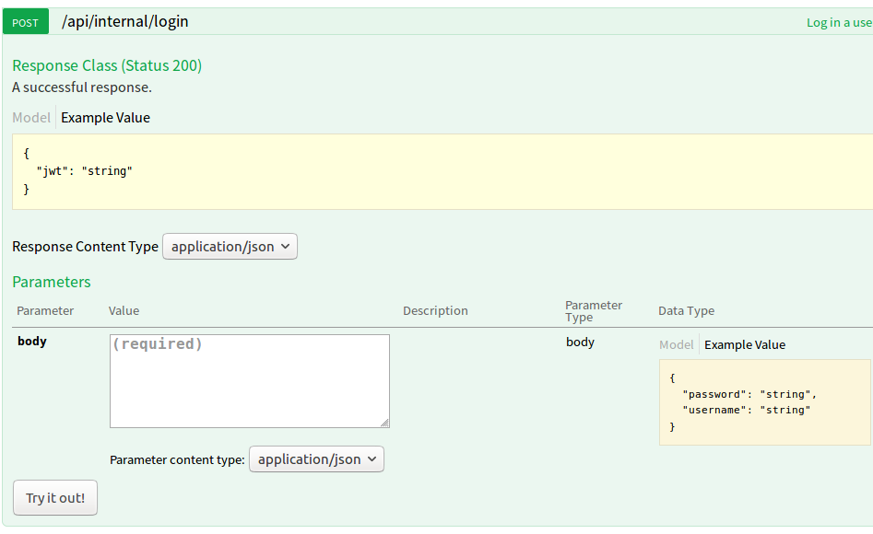

1. Enter the following in "body" and click on "try it out"码

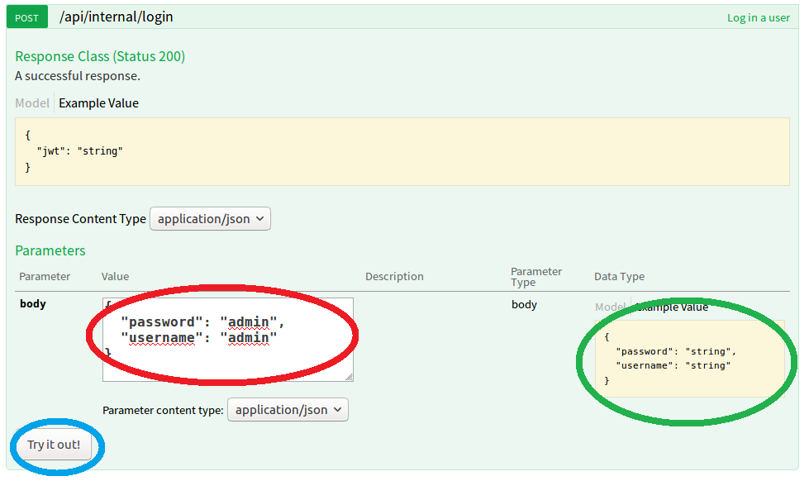

1. Copy the contents of the red area below

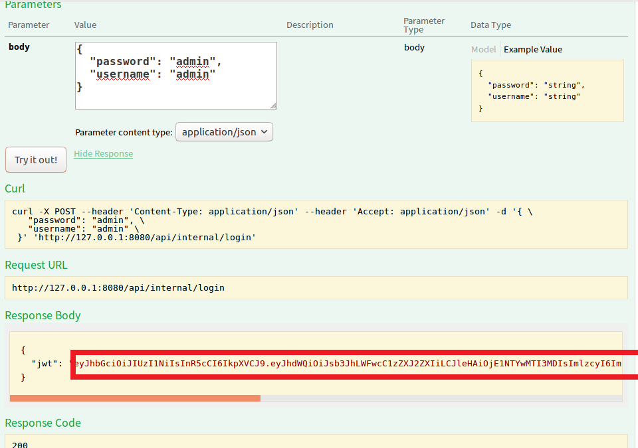

1. Then copy the content you just copied to the "jwt token" in the top right corner of the browser.

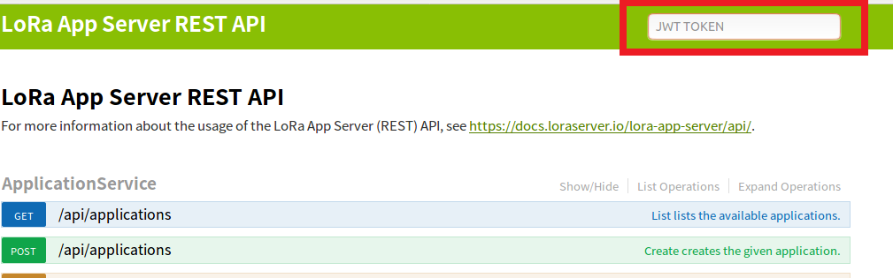

1. Click Enter, then refresh the page
2. Find the red rectangle box content "device_queue_item.dev_eui" in the figure below. After clicking Expand, enter the node EUI to receive data in the green area. Enter the following content in the red oval area. The data part is the base64 encoding of Hello. Finally, click Try it. Out, the node can receive the data, the node receives the Hello hexadecimal, which is 48656c6c6f：

{

"deviceQueueItem": {

"confirmed": true,

"data": "SGVsbG8=",

"fPort": 10

}

}

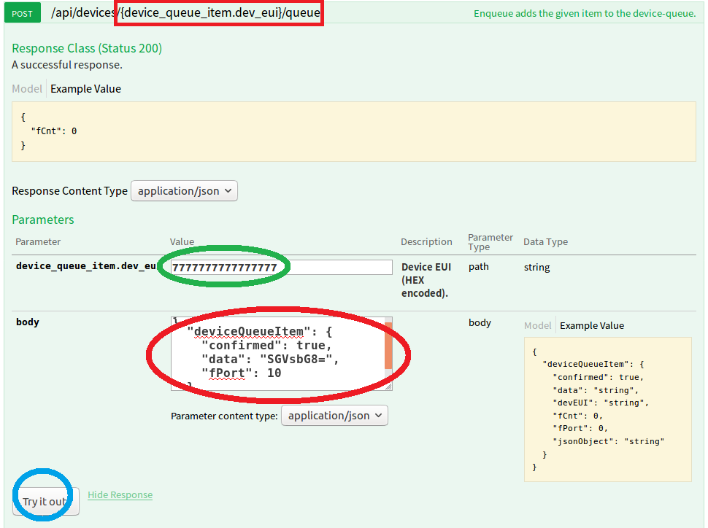

1. Note:
   1. The node must send a data after the join succeeds.